**Assignment on Zenmap**

**Submitted by : Madhur Nagrath**

**Roll No. 19csu169**

Perform the following commands using zenmap and attach the screenshot

Q1. Find the difference between 2 hosts information

1. Intense scan

|  |  |
| --- | --- |
| Chloeting.com | Localhost |

1. Quick scan

For localhost:

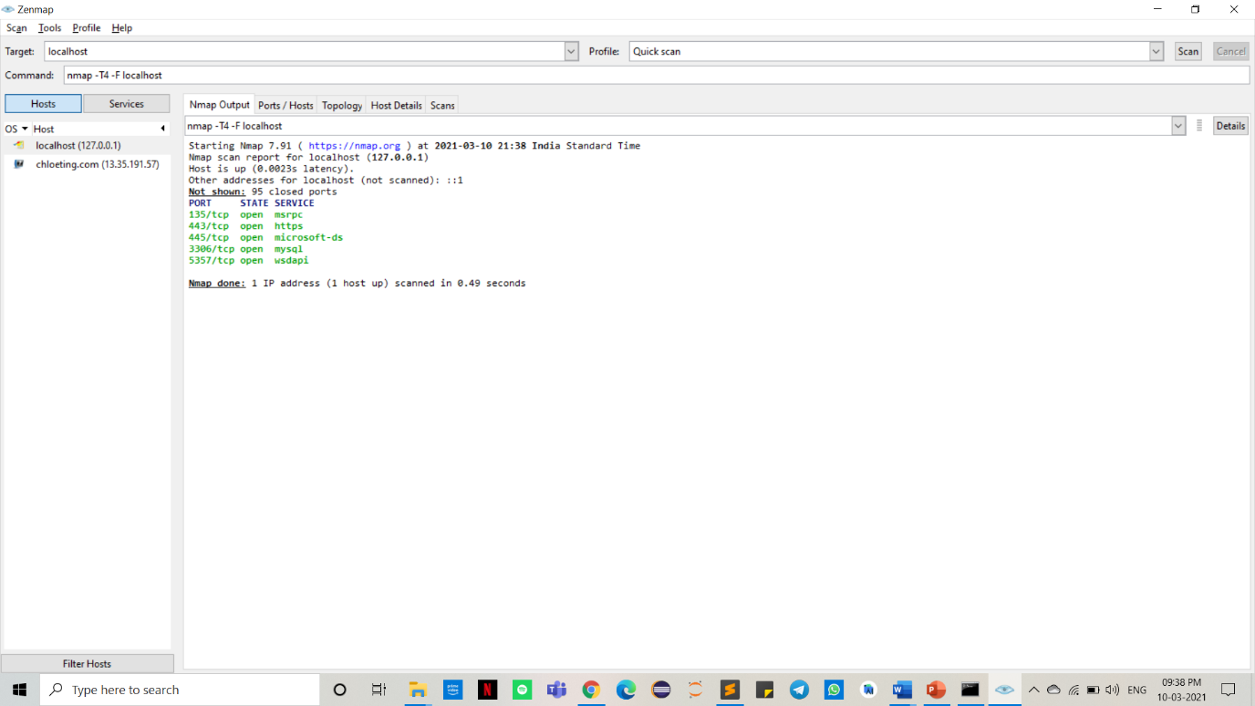

For chloeting.com:

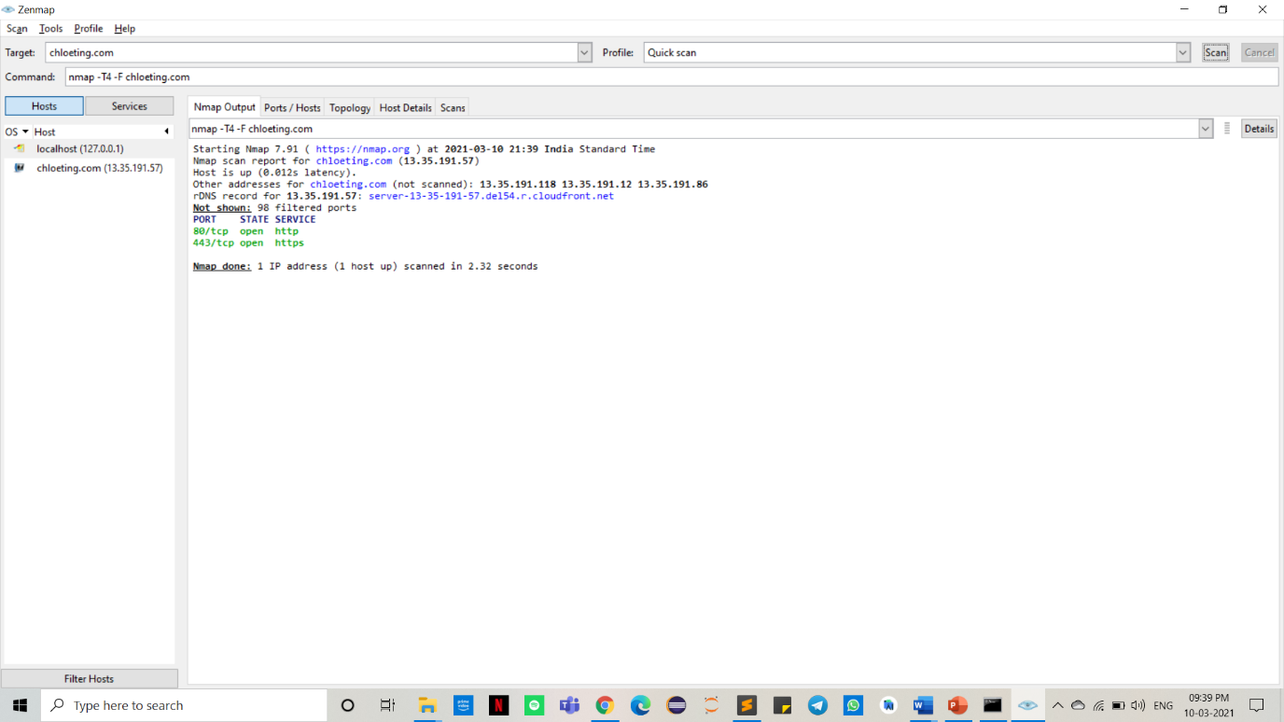

1. 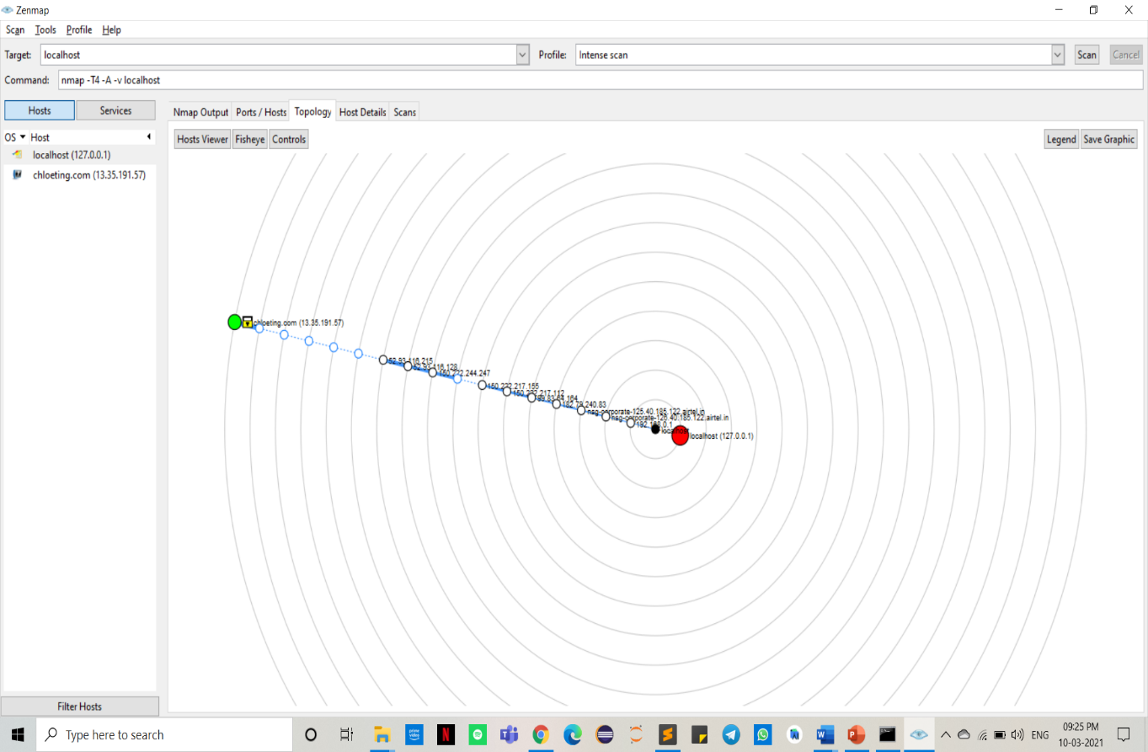Merge/ compare two scans

Q2. Run scripts in Zenmap to find vulnerabilities

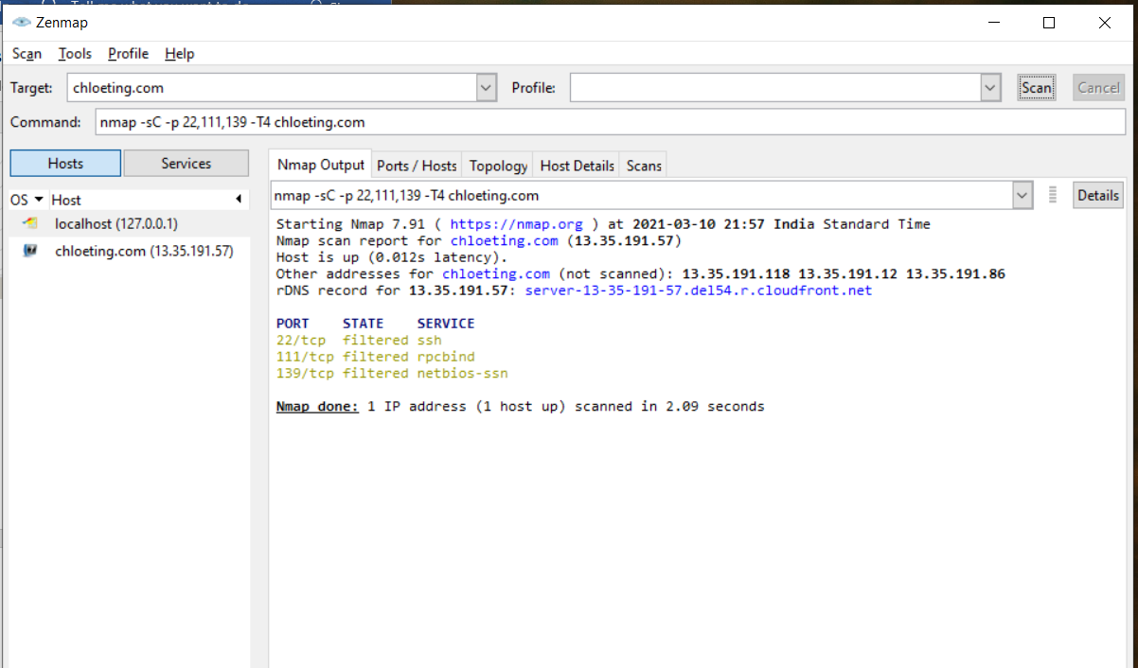

Q3. Find if the firewall is enabled or disabled using Zenmap

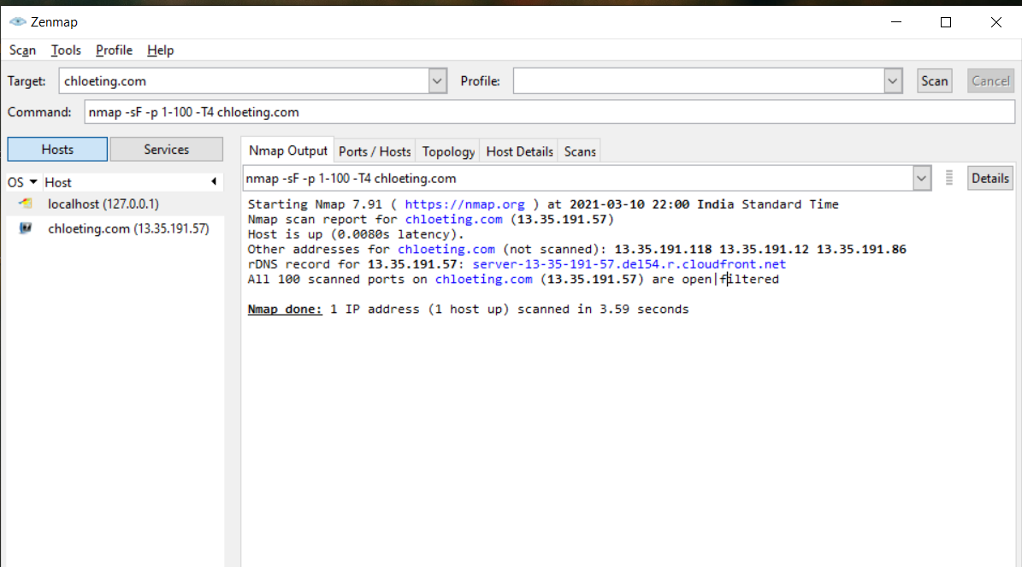

Q4. Execute TCP, UDP, Stealthy, Window, TCP ACK Scan

TCP scan :

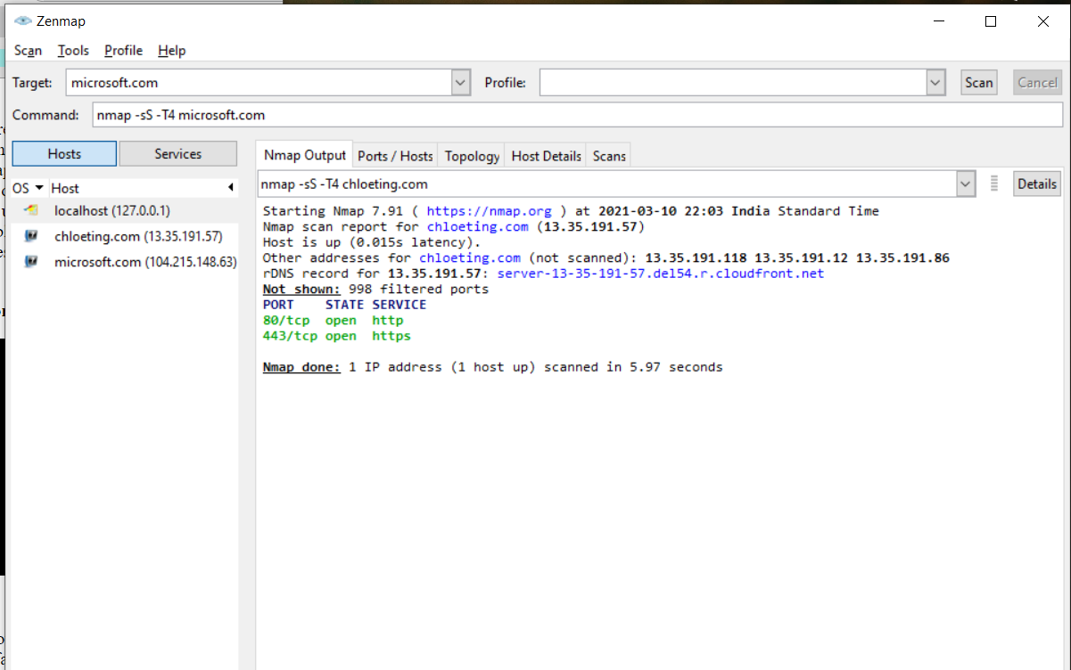

For UDP scan: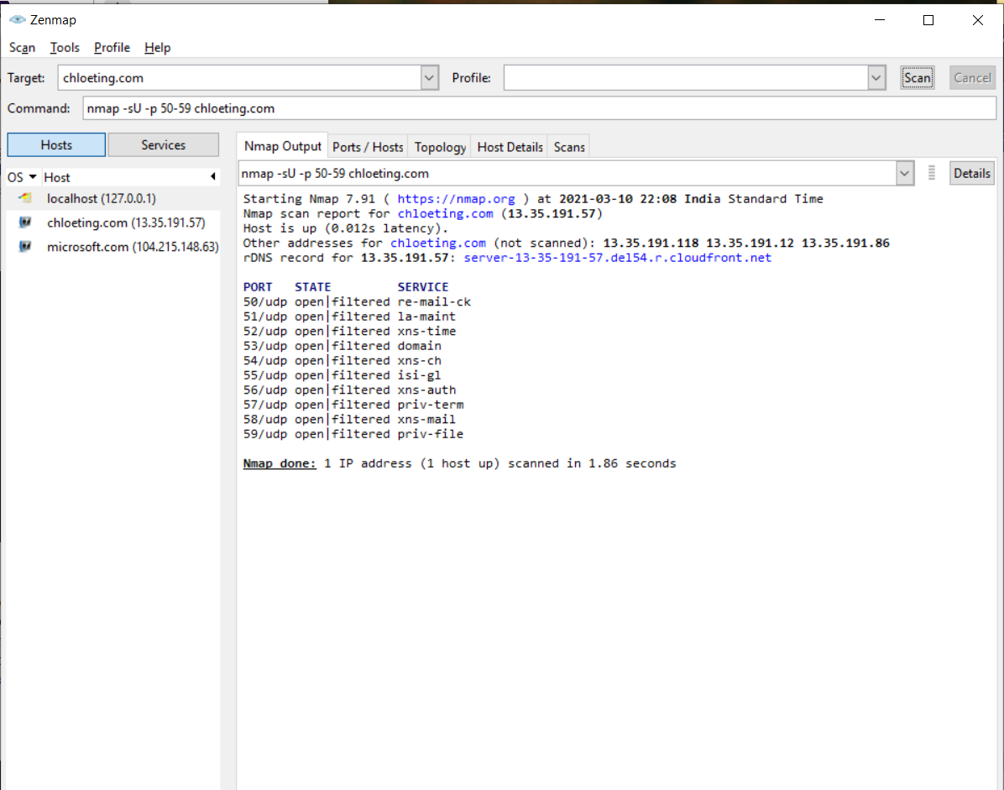

For stealthy scan :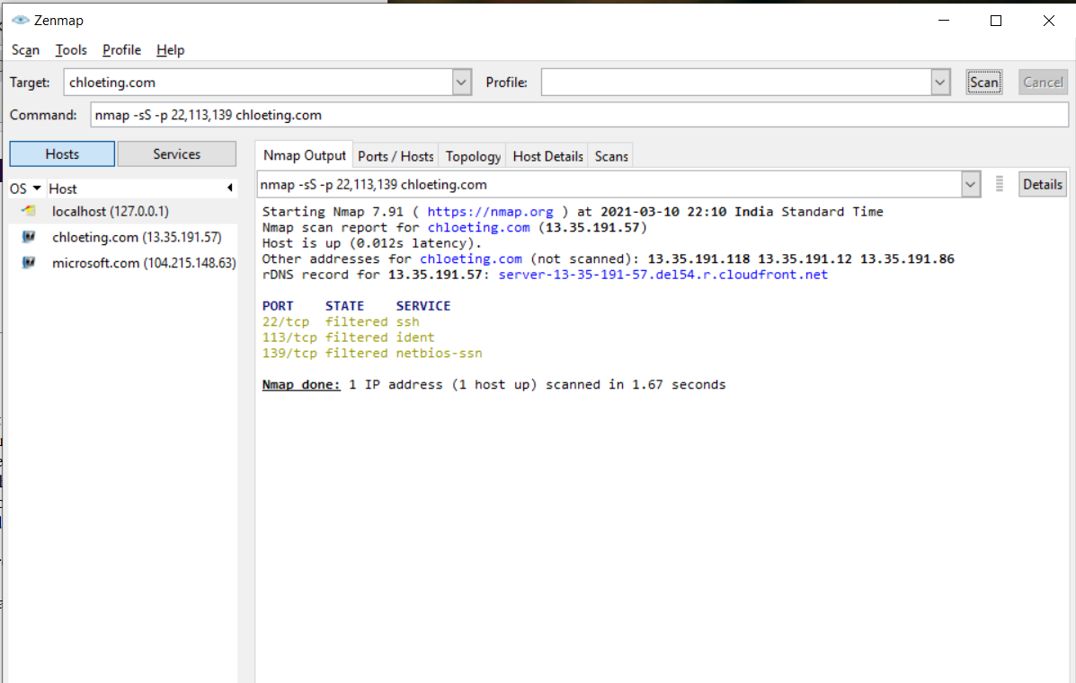

For windows scan:

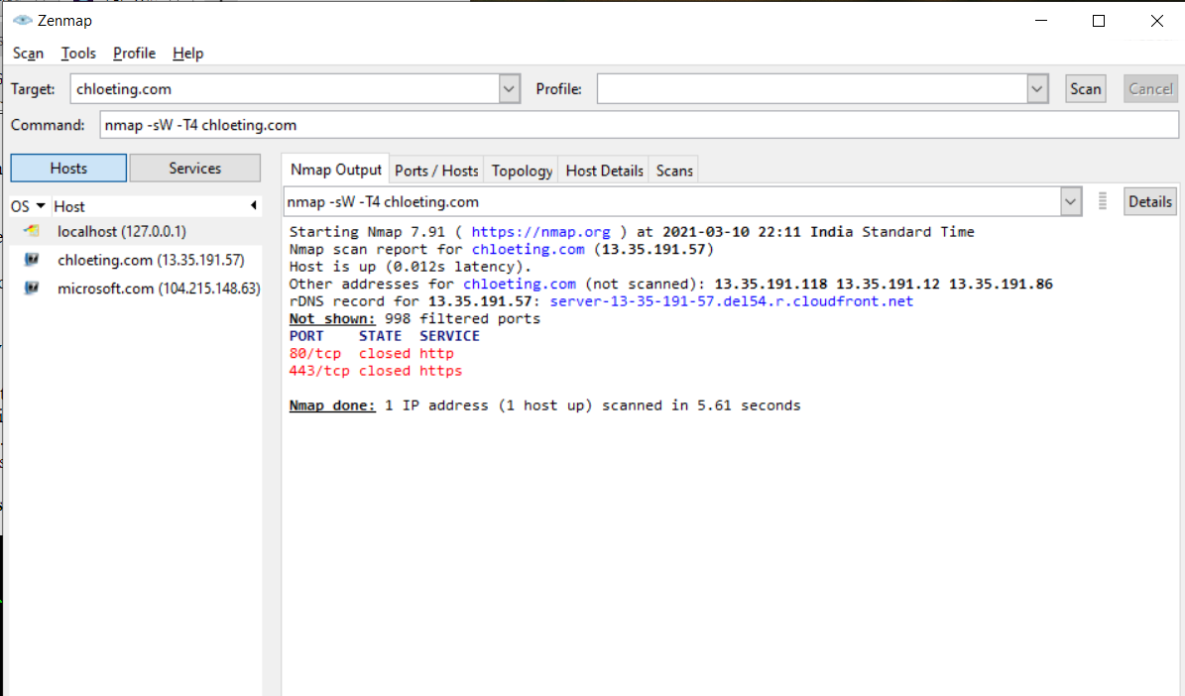

For TCP ACK scan:

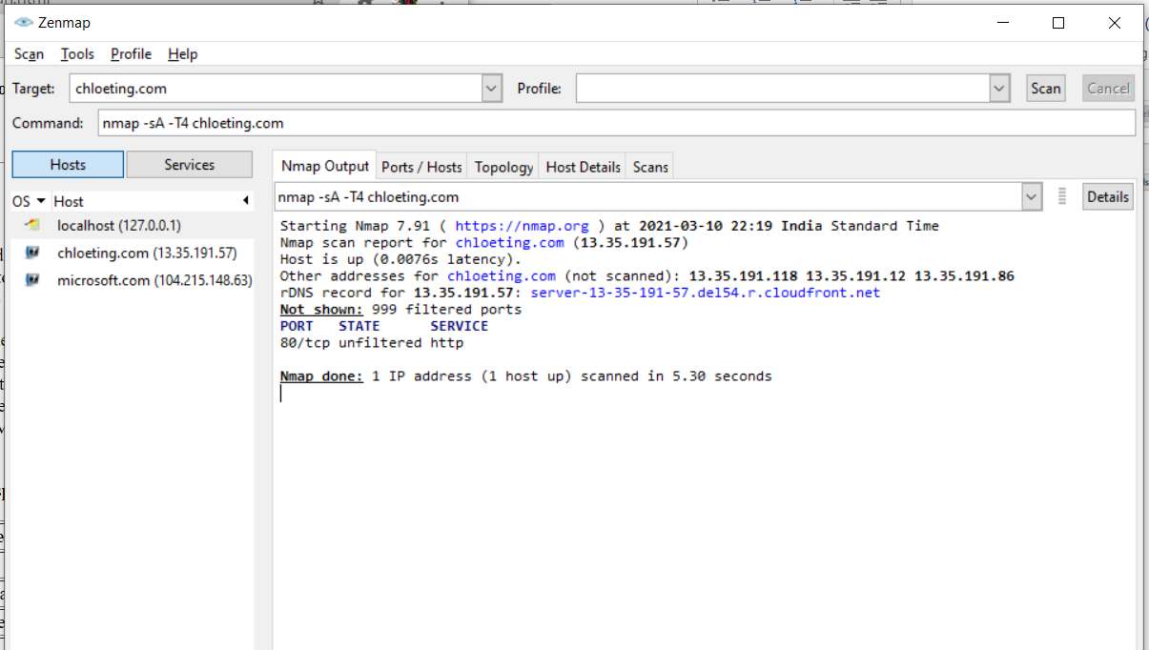

Q5. Trace the route for any scan

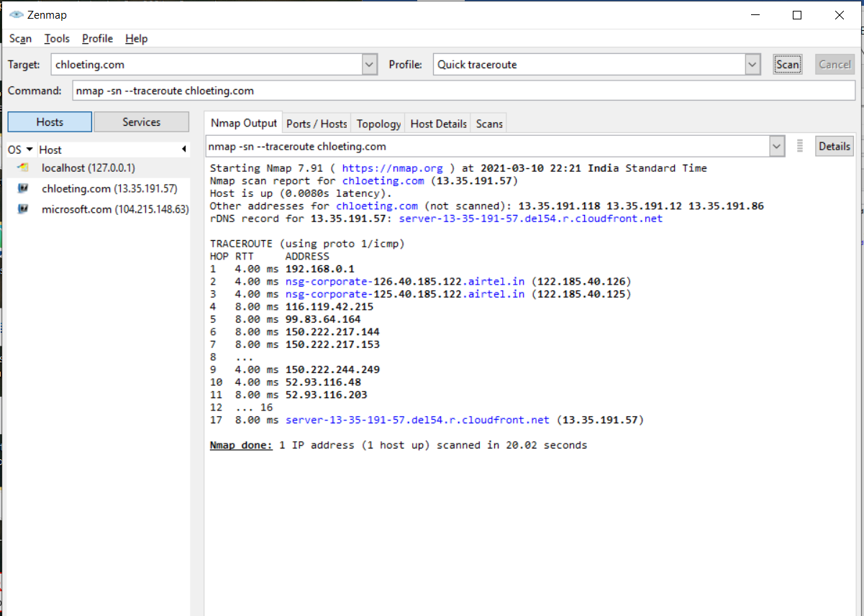

Q6. Perform fast aggressive scan on target

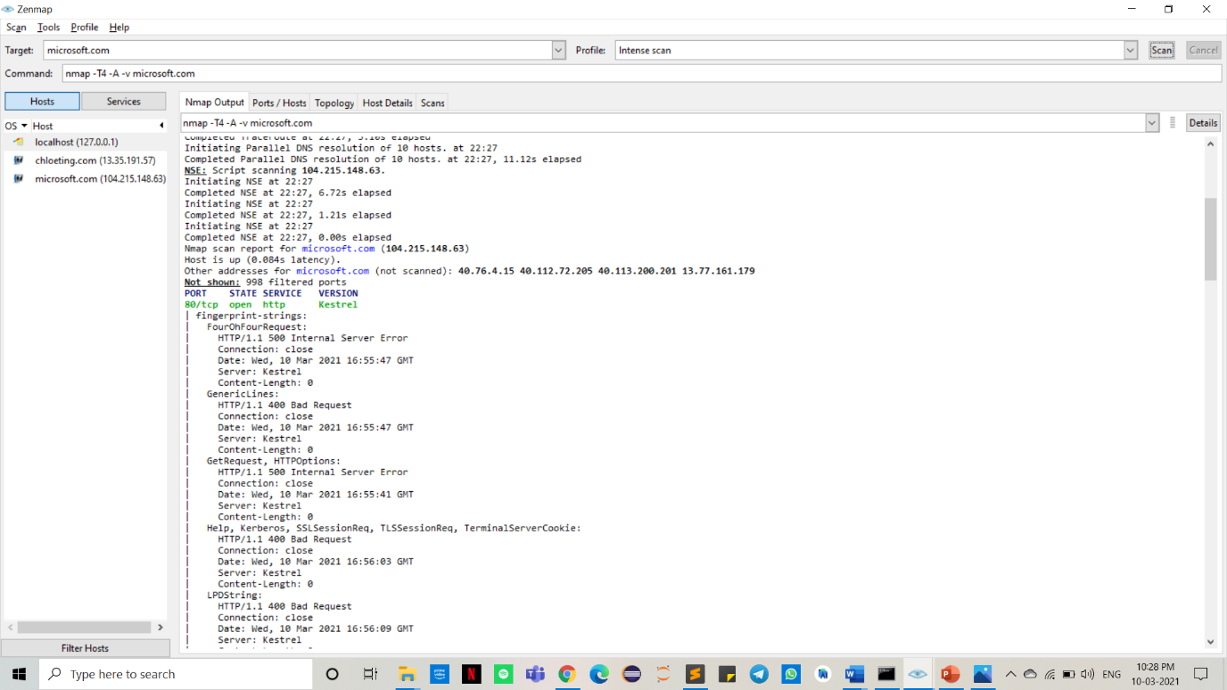

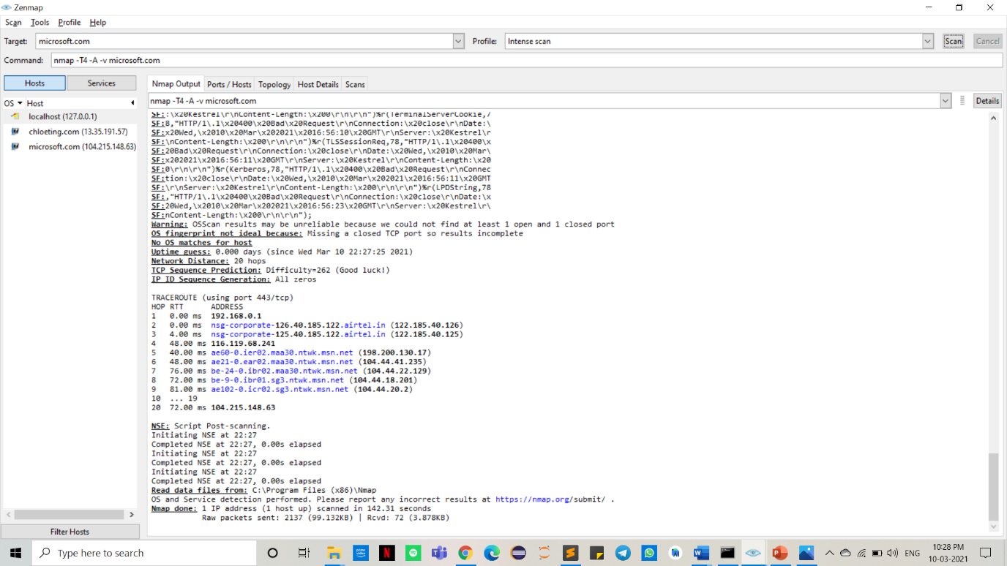

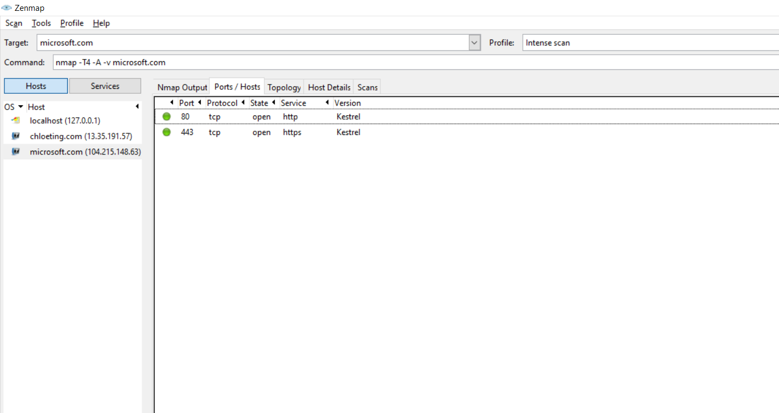

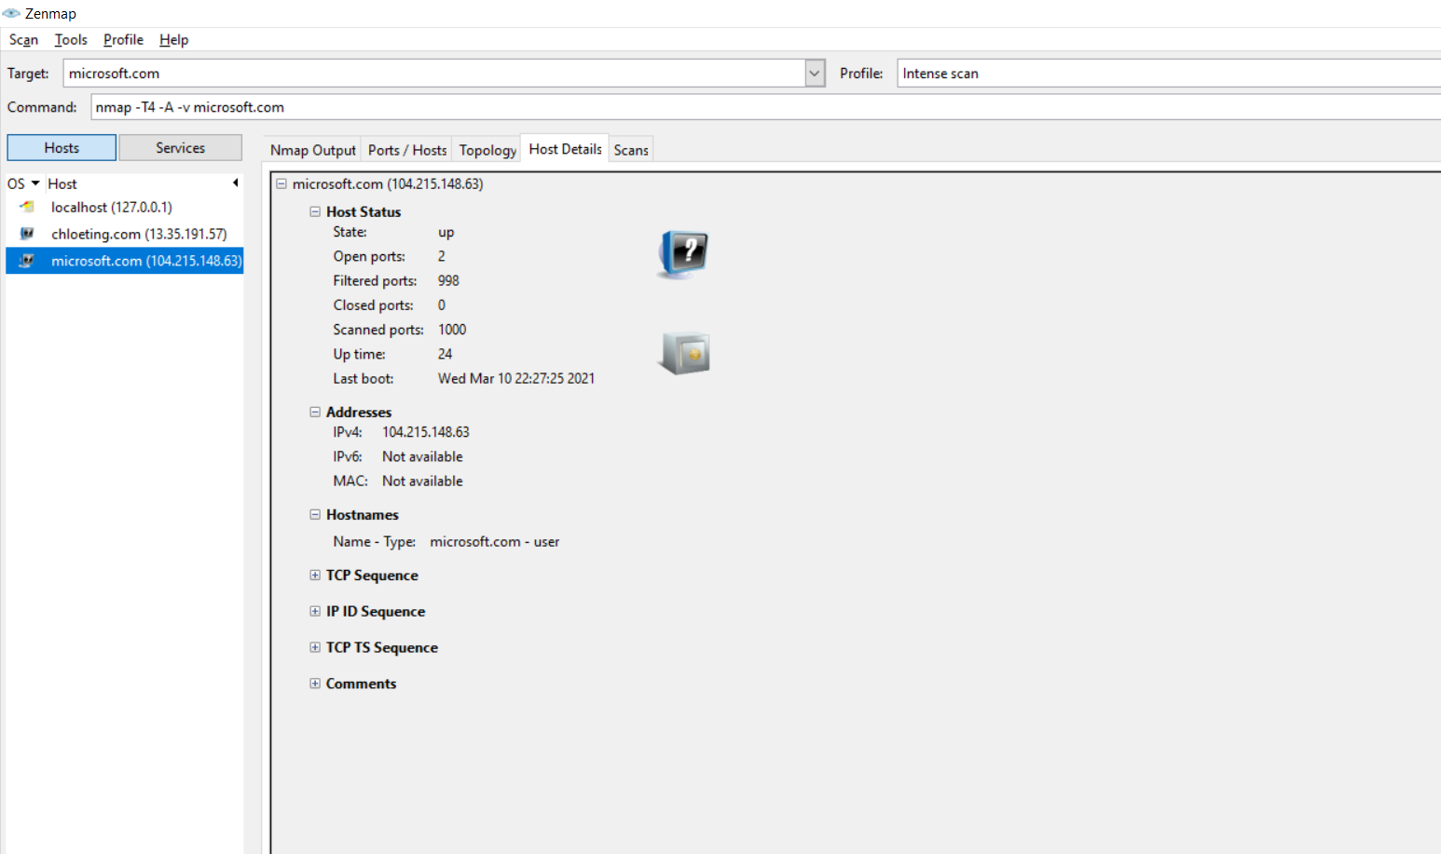

Q7. Perform UDP port scanning for all 65535 ports

